Test Case: tc003_SPX_Dev5_Crear_Requisicion_Spot_Tipo_Cobro_CC_Urgent
Step 1 - Enter username and password and click to button Enter : Credentials Entered
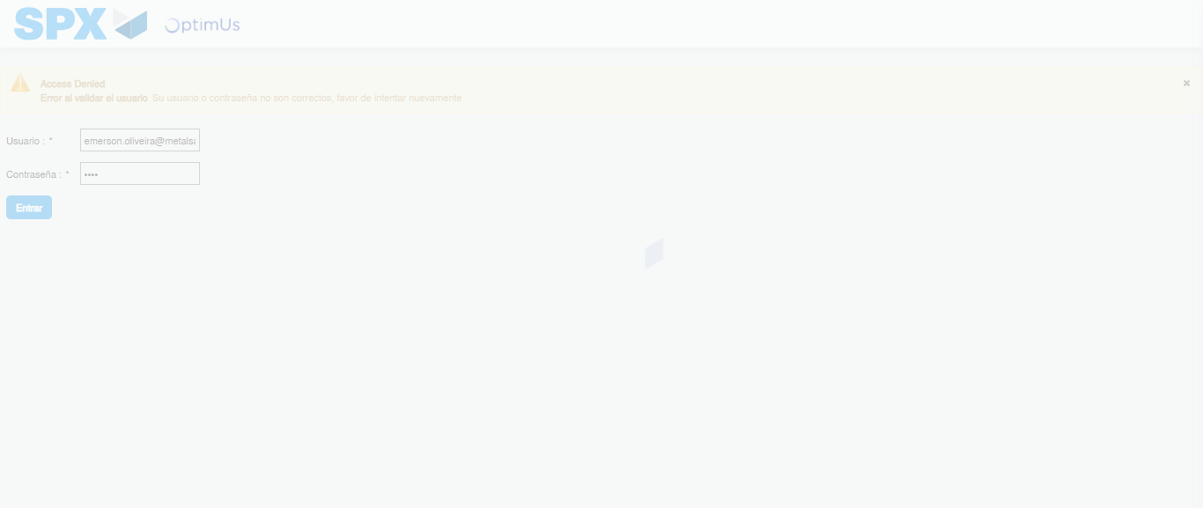Image file-name: QC_Testing-tc003_SPX_Dev5_Crear_Requisicion_Spot_Tipo_Cobro_CC_Urgent-1781744873879

Step 2 - Select to UEN and Access to Spot Buy Requisitions : UEN Correctly selected and Correct access
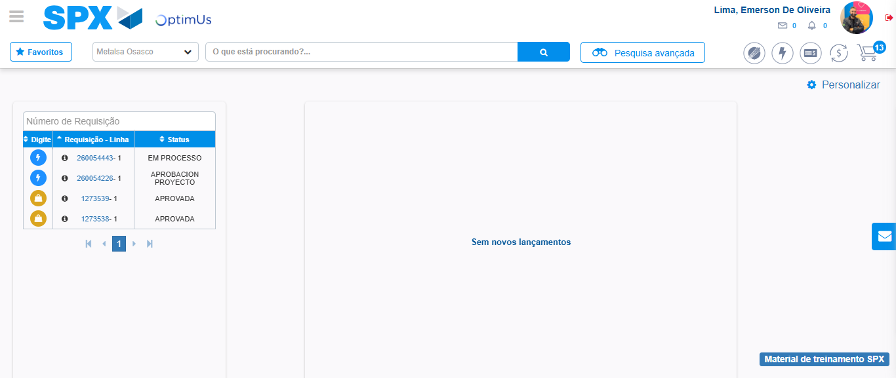Image file-name: QC_Testing-tc003_SPX_Dev5_Crear_Requisicion_Spot_Tipo_Cobro_CC_Urgent-1781744947606

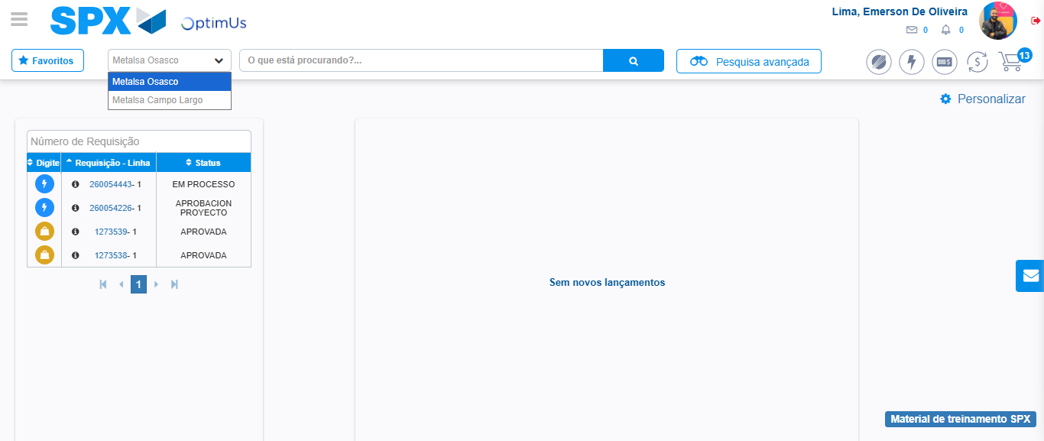Image file-name: QC_Testing-tc003_SPX_Dev5_Crear_Requisicion_Spot_Tipo_Cobro_CC_Urgent-1781744950123

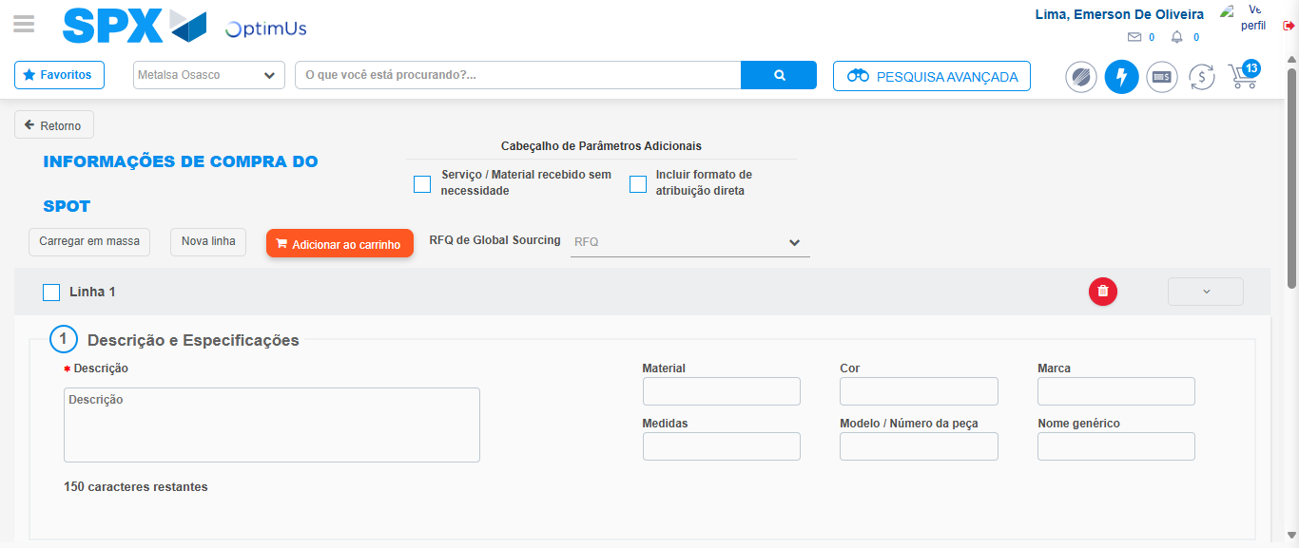Image file-name: QC_Testing-tc003_SPX_Dev5_Crear_Requisicion_Spot_Tipo_Cobro_CC_Urgent-1781744961526

Step 3 - Data Capture Spot Buy Requisition: Data captured correctly
Image file-name: QC_Testing-tc003_SPX_Dev5_Crear_Requisicion_Spot_Tipo_Cobro_CC_Urgent-1781744961777

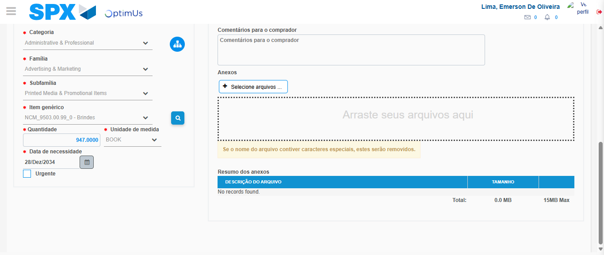Image file-name: QC_Testing-tc003_SPX_Dev5_Crear_Requisicion_Spot_Tipo_Cobro_CC_Urgent-1781744974337

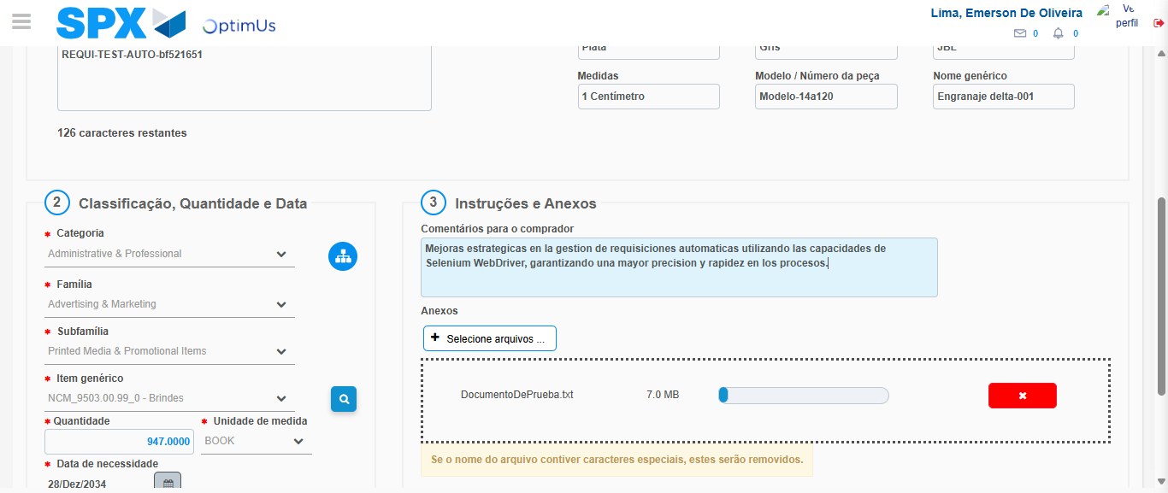Image file-name: QC_Testing-tc003_SPX_Dev5_Crear_Requisicion_Spot_Tipo_Cobro_CC_Urgent-1781744975252

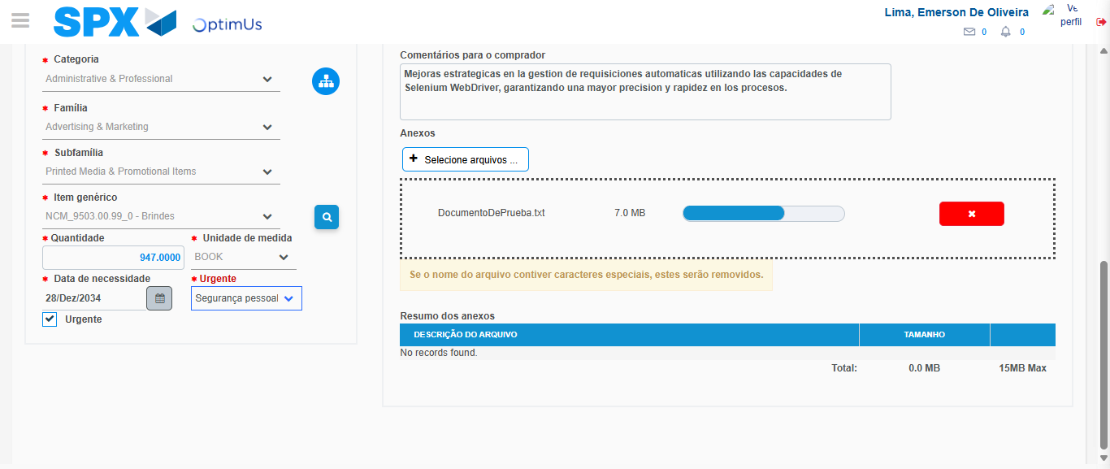Image file-name: QC_Testing-tc003_SPX_Dev5_Crear_Requisicion_Spot_Tipo_Cobro_CC_Urgent-1781744979108

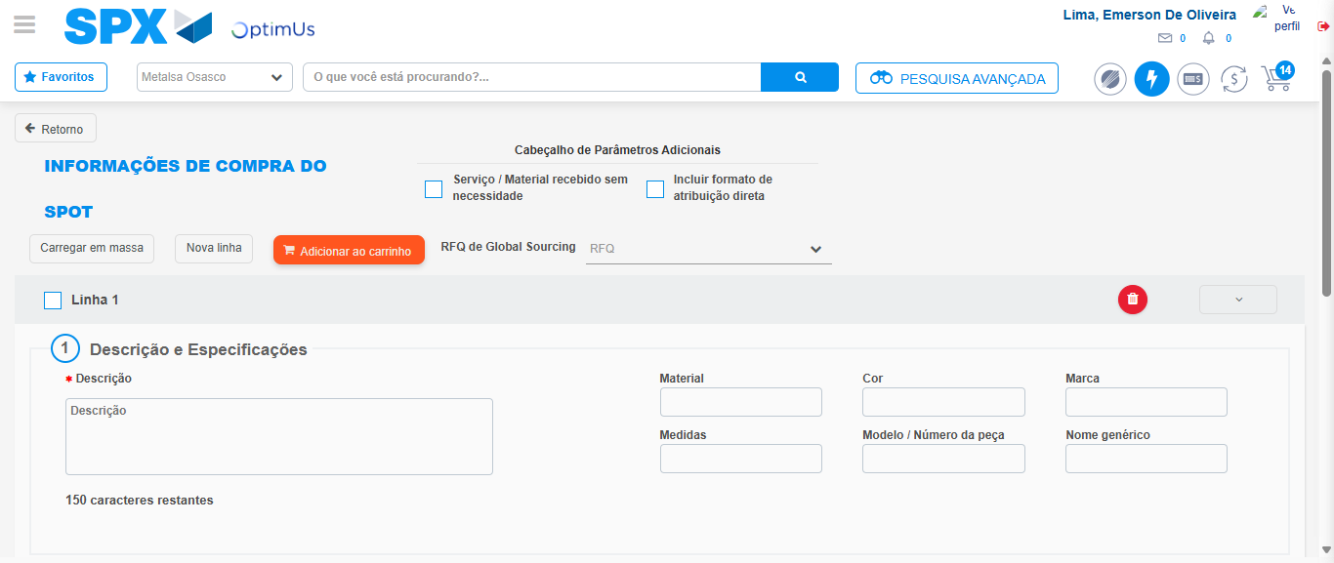Image file-name: QC_Testing-tc003_SPX_Dev5_Crear_Requisicion_Spot_Tipo_Cobro_CC_Urgent-1781744981096

Step 4 - Select to Requisition: Requisition Correctly selected
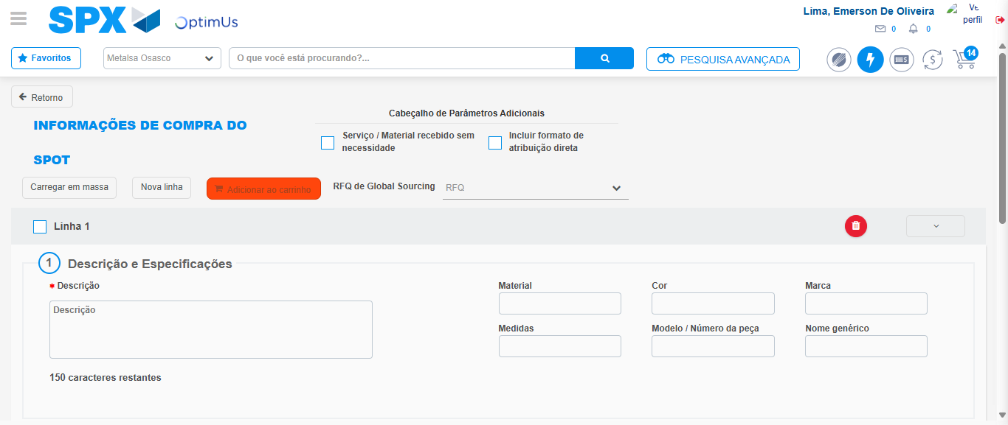Image file-name: QC_Testing-tc003_SPX_Dev5_Crear_Requisicion_Spot_Tipo_Cobro_CC_Urgent-1781744981286

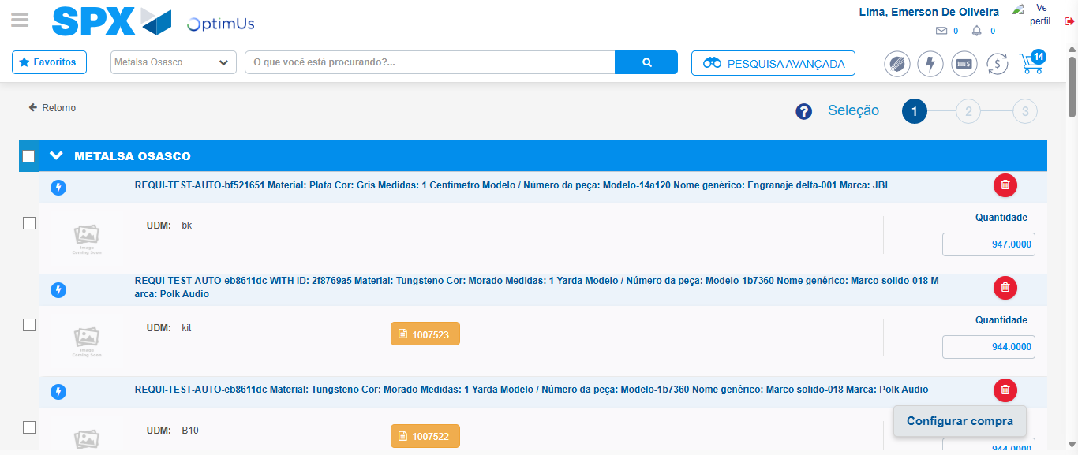Image file-name: QC_Testing-tc003_SPX_Dev5_Crear_Requisicion_Spot_Tipo_Cobro_CC_Urgent-1781744993669

Image file-name: QC_Testing-tc003_SPX_Dev5_Crear_Requisicion_Spot_Tipo_Cobro_CC_Urgent-1781744993889

Image file-name: QC_Testing-tc003_SPX_Dev5_Crear_Requisicion_Spot_Tipo_Cobro_CC_Urgent-1781744994092

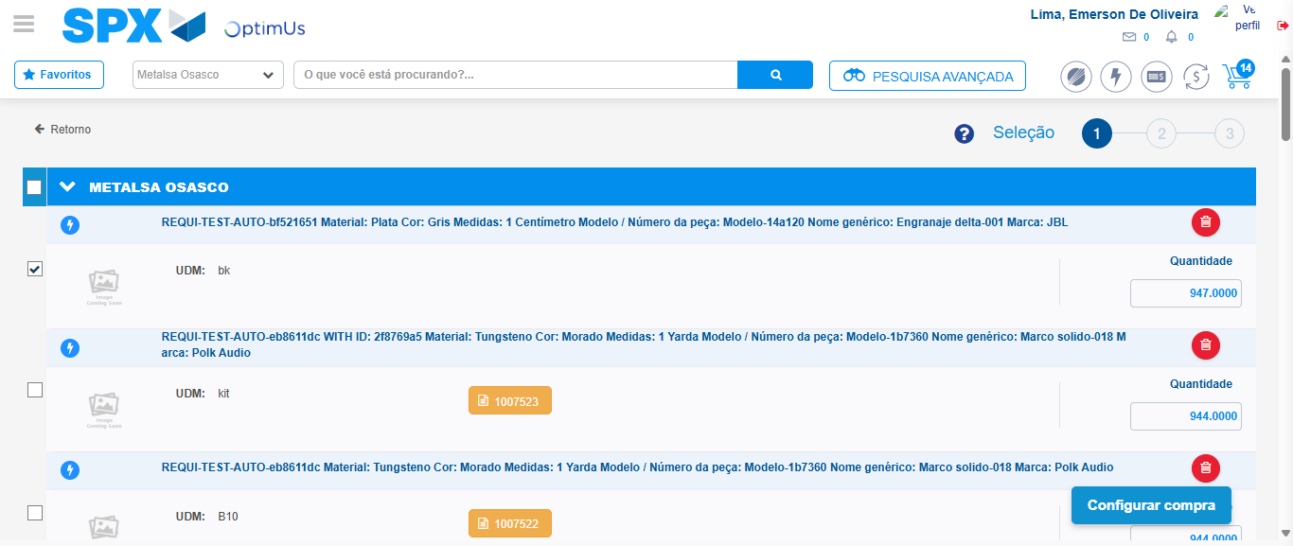Image file-name: QC_Testing-tc003_SPX_Dev5_Crear_Requisicion_Spot_Tipo_Cobro_CC_Urgent-1781744994936

Step 5 - Select Type Account For Requisition: Type Account Correctly selected
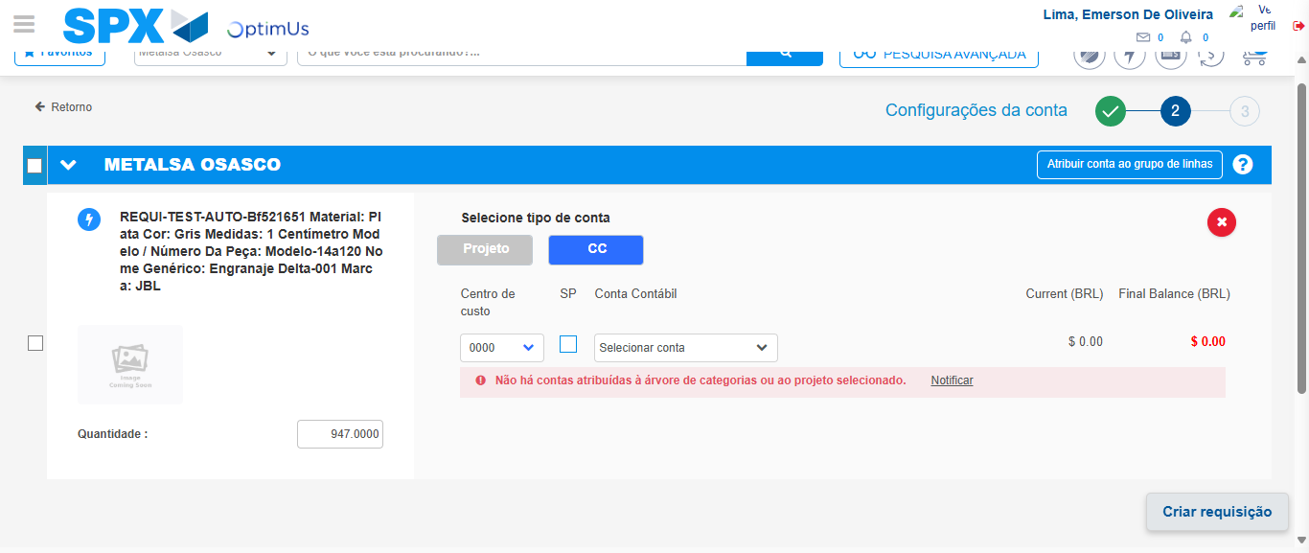Image file-name: QC_Testing-tc003_SPX_Dev5_Crear_Requisicion_Spot_Tipo_Cobro_CC_Urgent-1781745015217

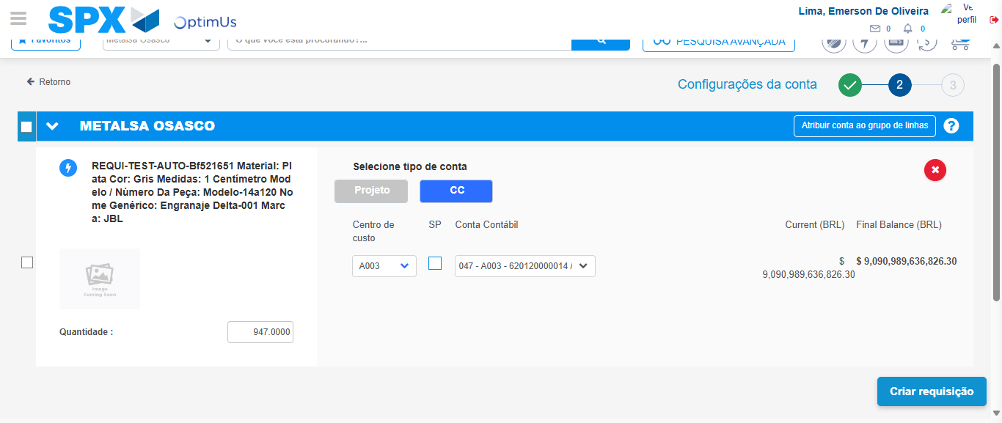Image file-name: QC_Testing-tc003_SPX_Dev5_Crear_Requisicion_Spot_Tipo_Cobro_CC_Urgent-1781745020051

Image file-name: QC_Testing-tc003_SPX_Dev5_Crear_Requisicion_Spot_Tipo_Cobro_CC_Urgent-1781745020223

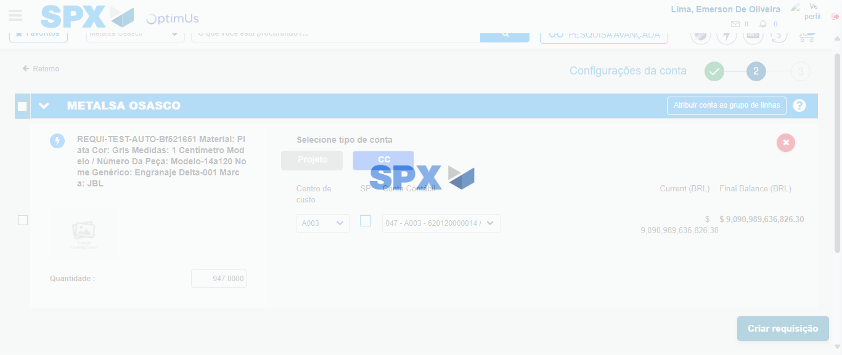Image file-name: QC_Testing-tc003_SPX_Dev5_Crear_Requisicion_Spot_Tipo_Cobro_CC_Urgent-1781745020612

Step 6 - Accept to Requisition: Requisition Accepted
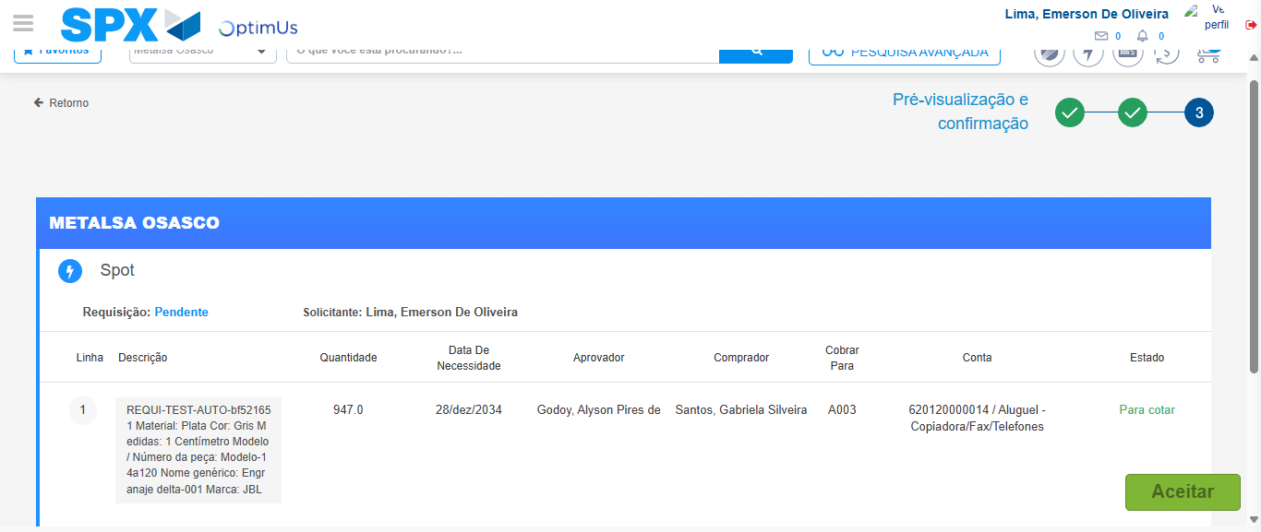Image file-name: QC_Testing-tc003_SPX_Dev5_Crear_Requisicion_Spot_Tipo_Cobro_CC_Urgent-1781745021944

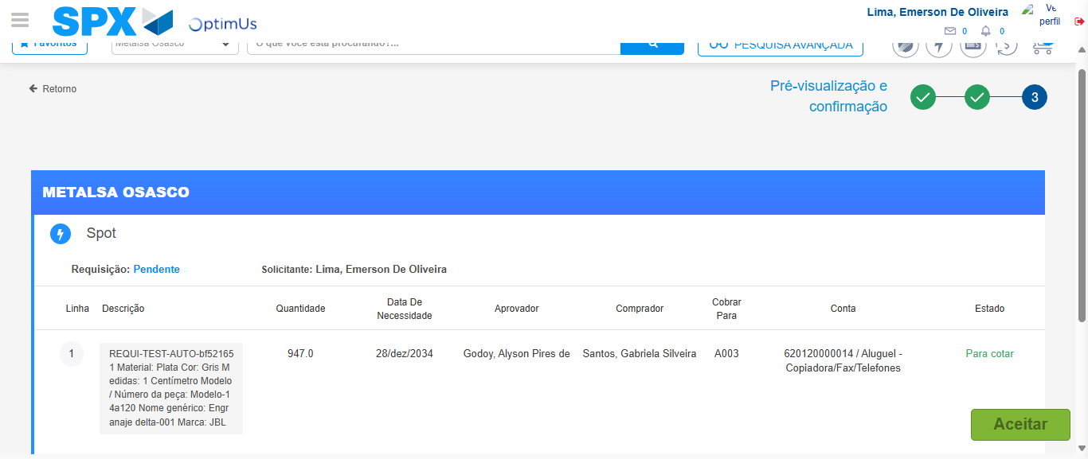Image file-name: QC_Testing-tc003_SPX_Dev5_Crear_Requisicion_Spot_Tipo_Cobro_CC_Urgent-1781745022155

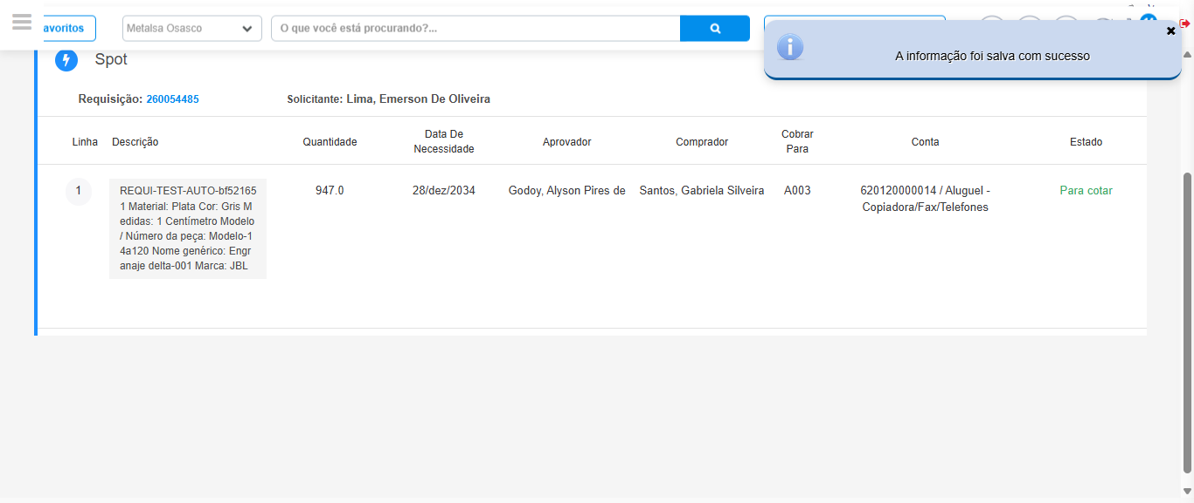Image file-name: QC_Testing-tc003_SPX_Dev5_Crear_Requisicion_Spot_Tipo_Cobro_CC_Urgent-1781745025601

Step 7 - Return to Main Page SPX : Return to Main Page SPX
Image file-name: QC_Testing-tc003_SPX_Dev5_Crear_Requisicion_Spot_Tipo_Cobro_CC_Urgent-1781744947606

Image file-name: QC_Testing-tc003_SPX_Dev5_Crear_Requisicion_Spot_Tipo_Cobro_CC_Urgent-1781744950123

Image file-name: QC_Testing-tc003_SPX_Dev5_Crear_Requisicion_Spot_Tipo_Cobro_CC_Urgent-1781744961526

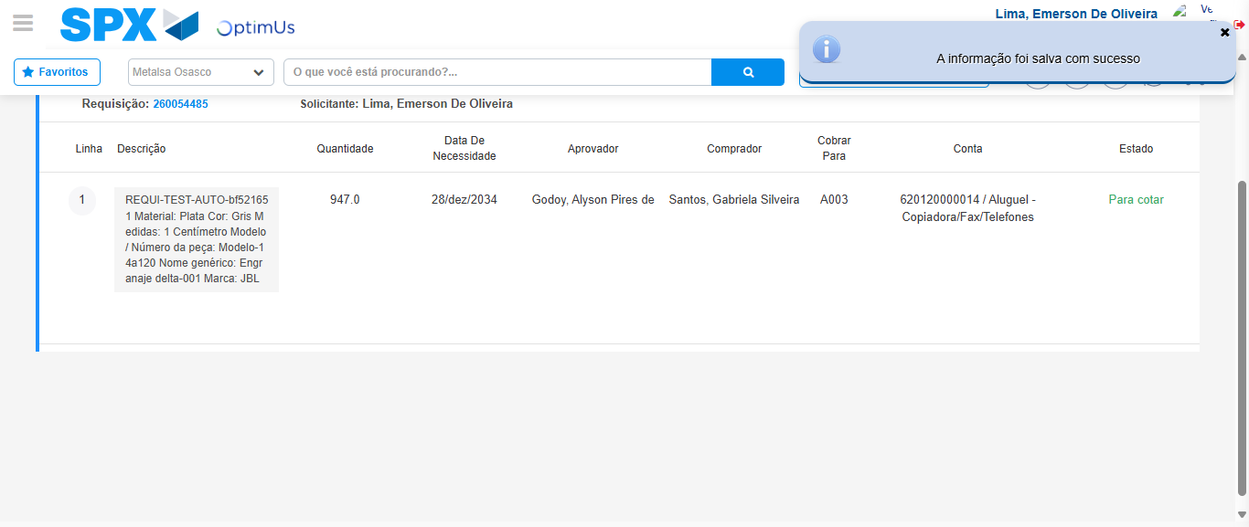Image file-name: QC_Testing-tc003_SPX_Dev5_Crear_Requisicion_Spot_Tipo_Cobro_CC_Urgent-1781745027832

Image file-name: QC_Testing-tc003_SPX_Dev5_Crear_Requisicion_Spot_Tipo_Cobro_CC_Urgent-1781745028008

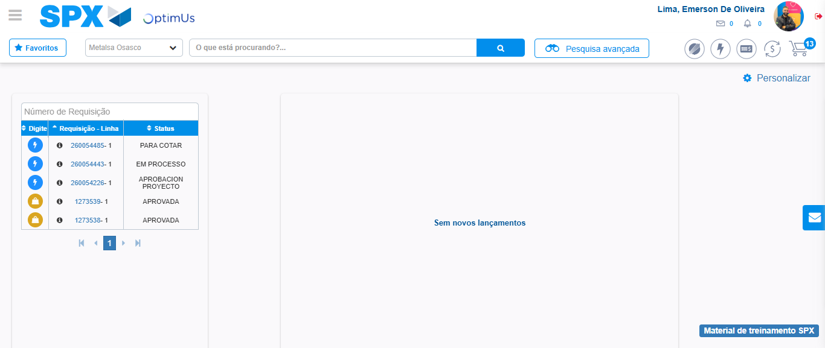Image file-name: QC_Testing-tc003_SPX_Dev5_Crear_Requisicion_Spot_Tipo_Cobro_CC_Urgent-1781745048991

Step 8 - Log Out : Log Out SPX
Image file-name: QC_Testing-tc003_SPX_Dev5_Crear_Requisicion_Spot_Tipo_Cobro_CC_Urgent-1781745049165

